Challenges

1. **StaleElementReferenceException**

**When web page or section of web page got refreshed**

**Stale means something is not fresh**

**Sometimes automatically page got refreshed and the element some where is not visible on the page**

**Suppose we have web page with some web elements and ajax**

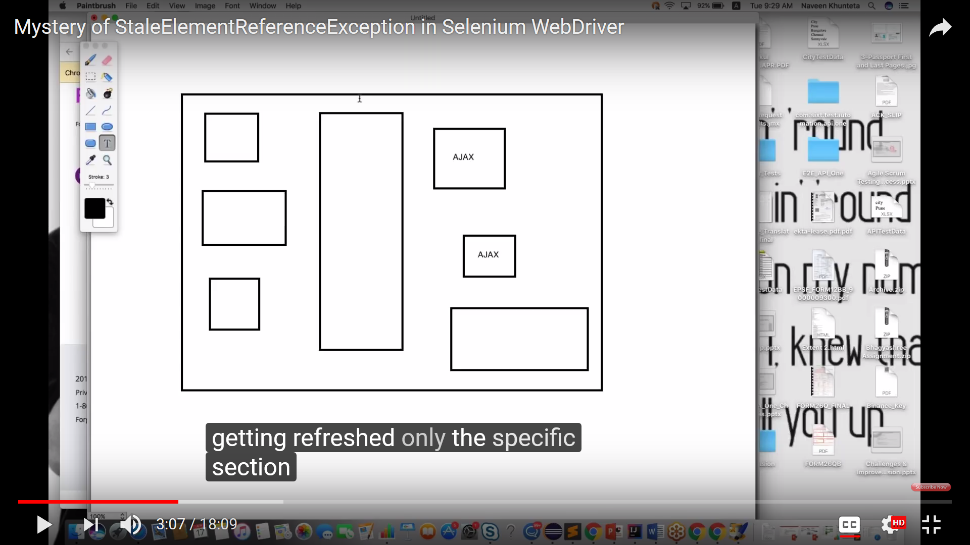

**Ajax means its like the web element you no need to refresh hole page specific element will refresh in page called ajax.**

**Getting refreshed only the specific section on the webpage called ajax call**

**Particular component got refreshed and you never refreshed your entire page.**

**Your element was presented in DOM but small document part of that element got refreshed so we are getting this error.We can handle this by waits.**

## Common Causes

A stale element reference exception is thrown in one of two cases, the first being more common than the second:

* The element has been deleted entirely.
* When The element is no longer attached to the DOM (some part of the HTML code for that element got refreshed.

## Multi-tab Testing

Selenium WebDriver has the ability to test in multiple tabs, but it might present as an obstacle if you don’t know the correct commands. For example, if you want to open a new tab to perform a specific action without leaving the original tab, you’ll still want to be able to control both tabs and go back to the parent tab if users are likely to perform these kinds of actions. The best method for this is to store the previous window handle in a variable and then continue in the new window and store that in a second variable. Then, you can use the switchTo method to go between both windows as needed.

## Dynamic Content

A web page that has dynamically loaded content has elements that may not be at first visible when you visit the site. This can mean that the page is user specific and will display different content based on different users, new content appears on the page after a certain amount of time, or it appears after clicking something on the page. For when a locator cannot identify a new element present at that time, Selenium WebDriver comes with an integrated [Explicit Wait](https://help.crossbrowsertesting.com/selenium-testing/getting-started/python/) where you can specify an amount of time to wait before automating a command. This should help give the page enough time to load and identify the element to interact with.

## Pop-up Windows

When a simple, prompt, or confirmation alert pops-up, it can be difficult to automate it to either accept or close. Additionally, Windows-based alerts are beyond Selenium’s capabilities since they’re part of the operating system instead of the browser. However, since Selenium WebDriver can operate multiple windows, web-based alerts can usually be handled with the switchTo method to control the pop-up while keeping the browser in the background.

tell me the 5 challenges you faced in selenium

I have faced so many challenges in my current project using Test automation using selenium.

Ours is An **enterprise application** and insurance domain and operating environment is windows 10 at client side and server side is windows 2008 server,

As per the customer requirement we need to conduct browser compatibility testing also apart from main functional testing.

Our selenium test scripts were executed properly in Mozilla Firefox browser. But in IE now a day’s new name is Microsoft edge in IE internet explorer browser we faced so many issues like

Timeout problems synchronization problems. Later we rectified those problems and finally we found that IE browser is slower than Firefox browser in test case execution.

We faced some difficulties in handling dynamic elements in our web pages.

We faced some issues while handling some dynamic web table to extract some data.

finally it is not a challenge we have spent more time than expected on selenium automation due to framework implementation and no built-in object repository in selenium and no built-in result report facility in selenium.